DEEP LEARNING LABORATORY MANUAL

(19AI24601)

For VI-Semester B.Tech AI & DS



MAHENDRA ENGINEERING COLLEGE
(AUTONOMOUS)
Department of Artificial Intelligence & Data Science
Mahendhirapuri, Mallasamudram(W)
Namakkal-637 503.

MAHENDRA ENGINEERING COLLEGE
(Autonomous)
Syllabus
Department |  |  | Computer Science and Engineering | Programme  Code & Name |  |  |  |  |  | 1161
B.Tech – Artificial Intelligence & Data Science
VI Semester
Course  Code |  | Course Name |  |  | Hours /Week |  |  | Credit | Maximum  marks
 |  |  |  |  | L | T | P | C
19AI24601 |  | DEEP LEARNING LABORATORY |  |  | 0 | 0 | 4 | 2 | 100
Objective(s) |  | - To learn deep neural networks and apply for simple problem  - To Learn and apply Convolution Neural Network for image processing  - To Learn and apply Recurrent Neural Network and its variants for text analysis  - To augment data using generative models  - To explore real world applications with deep neural networks
Outcome(s) |  | - Apply deep neural network for simple problems  - Apply Convolution Neural Network for image processing  - Apply Recurrent Neural Network and its variants for text analysis  - Apply generative models for data augmentation  - Develop a real world application using suitable deep neural networks
LIST OF EXPERIMENTS
1. | Solving XOR problem using Multilayer perceptron
2. | Implement character and Digit Recognition using ANN.
3. | Implement the analysis of X-ray image using autoencoders
4. | Implement Speech Recognition using NLP
5. | Develop a code to design object detection and classification for traffic analysis using CNN
6. | Implement online fraud detection of share market data using any one of the data analytics tools
7. | Implement image augmentation using deep RBM.
8. | Implement Sentiment Analysis using LSTM.
9. | Mini Project: Number plate recognition of traffic video analysis.
TOTAL HOURS |  |  |  |  |  |  |  |  |  |  | 30

BoS Chairman

INDEX

S.NO | NAME OF THE EXPERIMENTS | PAGE NO.
1. | Solving XOR Problem using Multilayer Perceptron | 4
2.a | Implement Digit Recognition using ANN | 9
2.b | Implement Character Recognition using ANN | 11
3. | Implement the Analysis of X-ray Image using Autoencoders | 13
4. | Implement Speech Recognition using NLP | 16
5a. | Develop a code to design object detection using CNN | 21
5.b. | Develop a Code to Design Classification for Traffic Analysis using CNN | 25
6. | Implement Online Fraud Detection of Share Market Data using any one of the Data Analytics Tools | 28
7. | Implement Image Augmentation using Deep RBM | 33
8. | Implement Sentiment Analysis using LSTM | 37
9. | Mini Project: Number plate recognition of traffic video Analysis | 39

Exp No :1 | Solving XOR Problem using Multilayer Perceptron

AIM:
To solve XOR Problem using Multilayer Perceptron by Deep Learning module in Python Program.

PROCEDURE:
XOr logical Operator
XOr, or Exclusive Or, is a binary logical operator that takes in Boolean inputs and gives out True if and only if the two inputs are different. This logical operator is especially useful when we want to check two conditions that can't be simultaneously true. The following is the Truth table for XOr function
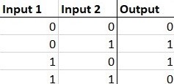
The XOr problem
The XOr problem is that we need to build a Neural Network (a perceptron in our case) to produce the truth table related to the XOr logical operator. This is a binary classification problem. Hence, supervised learning is a better way to solve it. In this case, we will be using perceptrons. Uni layered perceptrons can only work with linearly separable data. But in the following diagram drawn in accordance with the truth table of the XOr loical operator, we can see that the data is NOT linearly separable.
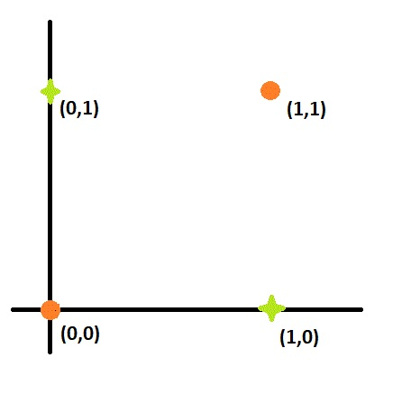
The Solution
To solve this problem, we add an extra layer to our vanilla perceptron, i.e., we create a Multi Layered Perceptron (or MLP). We call this extra layer as the Hidden layer. To

build a perceptron, we first need to understand that the XOr gate can be written as a combination of AND gates, NOT gates and OR gates in the following way:
a XOr b = (a AND NOT b)OR(bAND NOTa)
The following is a plan for the perceptron.
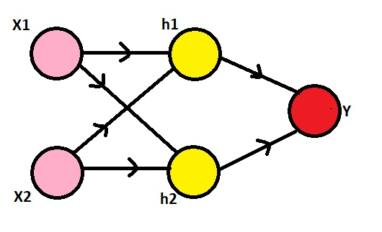
Here, we need to observe that our inputs are 0s and 1s. To make it a XOr gate, we will make the h1 node to perform the (x2 AND NOT x1) operation, the h2 node to perform (x1 AND NOT x2) operation and the y node to perform (h1 OR h2) operation. The NOT gate can be produced for an input a by writing (1-a), the AND gate can be produced for inputs a and b by writing (a.b) and the OR gate can be produced for inputs a and b by writing (a+b). Also, we'll use the sigmoid function as our activation function σ, i.e., σ(x) = 1/(1+e^(-x)) and the threshold for classification would be 0.5, i.e., any x with σ(x)>0.5 will be classified as 1 and others will be classified as 0.
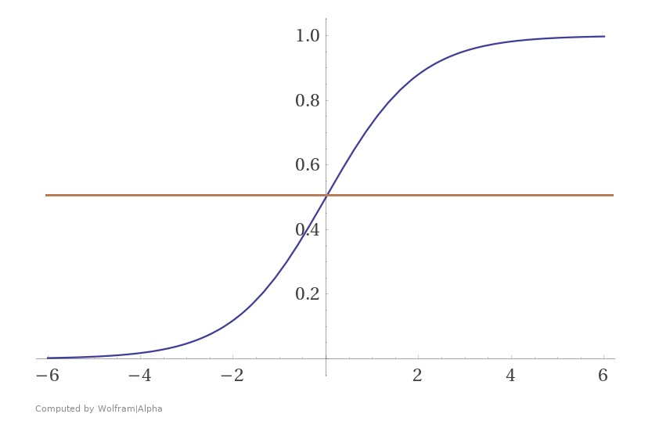
Now, since we have all the information, we can go on to define h1, h2 and y. Using the formulae for AND, NOT and OR gates, we get:
- h1 = σ((1-x1) + x2) = σ((-1)x1 + x2 + 1)
- h2 = σ(x1 + (1-x2)) = σ(x1 + (-1)x2 + 1)
- y = σ(h1 + h2) = σ(h1 + h2 + 0)
Hence, we have built a multi layered perceptron with the following weights and it predicts the output of a XOr logical operator.
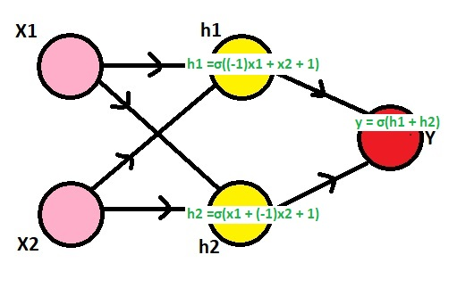

PROGRAM:

In[1]:
import numpy as np
np.random.seed(0)

def sigmoid(x): # Returns values that sums to one.
return 1 / (1 + np.exp(-x))

def sigmoid_derivative(sx):
# See https://math.stackexchange.com/a/1225116
return sx * (1 - sx)

# Cost functions.
def cost(predicted, truth):
return truth - predicted

xor_input = np.array([[0,0], [0,1], [1,0], [1,1]])
xor_output = np.array([[0,1,1,0]]).T

# Lets drop the last row of data and use that as unseen test.
X = xor_input
Y = xor_output
# Define the shape of the weight vector.
num_data, input_dim = X.shape
# Lets set the dimensions for the intermediate layer.

hidden_dim = 5
# Initialize weights between the input layers and the hidden layer.
W1 = np.random.random((input_dim, hidden_dim))

# Define the shape of the output vector.
output_dim = len(Y.T)
# Initialize weights between the hidden layers and the output layer.
W2 = np.random.random((hidden_dim, output_dim))

num_epochs = 10000
learning_rate = 1.0

for epoch_n in range(num_epochs):
layer0 = X
# Forward propagation.

# Inside the perceptron, Step 2.
layer1 = sigmoid(np.dot(layer0, W1))
layer2 = sigmoid(np.dot(layer1, W2))
# Back propagation (Y -> layer2)

# How much did we miss in the predictions?
layer2_error = cost(layer2, Y)
# In what direction is the target value?
# Were we really close? If so, don't change too much.
layer2_delta = layer2_error * sigmoid_derivative(layer2)

# Back propagation (layer2 -> layer1)
# How much did each layer1 value contribute to the layer2 error (according to the weights)?
layer1_error = np.dot(layer2_delta, W2.T)
layer1_delta = layer1_error * sigmoid_derivative(layer1)

# update weights
W2 += learning_rate * np.dot(layer1.T, layer2_delta)
W1 += learning_rate * np.dot(layer0.T, layer1_delta)

In[2]:
for x, y in zip(X, Y):
layer1_prediction = sigmoid(np.dot(W1.T, x)) # Feed the unseen input into trained W.
prediction = layer2_prediction = sigmoid(np.dot(W2.T, layer1_prediction)) # Feed the unseen input into trained W.
print(int(prediction > 0.5), y)

OUTPUT:
0 [0]
1 [1]
1 [1]
0 [0]

RESULT:
Thus the XOR Problem using Multilayer Perceptron by implementing Python Program is executed and verified successfully.

Exp No :2.a | Implement Digit Recognition using ANN

AIM:
To Implement Handwritten Digit recognition using Artificial Neural Network.

PROCEDURE:
In this machine learning project, we will recognize handwritten digits, i.e, numbers from 0-9. This we are going to achieve by modeling a neural network that will have to be trained over a dataset containing images of numbers.
Project Prerequisites
Below are the prerequisites for this project:
- Python (3.7.4 used)
- IDE (Jupyter used)
Required frameworks are
- Numpy (version 1.16.5)
- cv2 (openCV) (version 3.4.2)
- Keras (version 2.3.1)
- Tensorflow (Keras uses TensorFlow in backend and for some image preprocessing) (version 2.0.0)
- Matplotlib (version 3.1.1)
- Pandas (version 0.25.1)

DOWNLOAD DATASET:
Handwritten Character Recognition Dataset

PROGRAM:
import matplotlib.pyplot as plt
import cv2
import numpy as np
from keras.models import Sequential
from keras.layers import Dense, Flatten, Conv2D, MaxPool2D, Dropout
from keras.optimizers import SGD, Adam
from keras.callbacks import ReduceLROnPlateau, EarlyStopping

from keras.utils import to_categorical
import pandas as pd
import numpy as np
from sklearn.model_selection import train_test_split
from sklearn.utils import shuffle
data = pd.read_csv(r"D:\a-z alphabets\A_Z Handwritten Data.csv").astype('float32')
print(data.head(10))

OUTPUT:
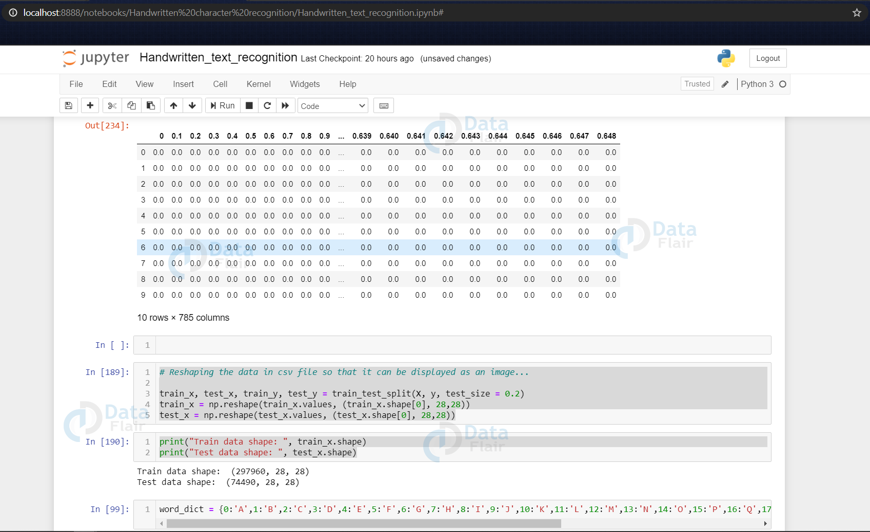

RESULT:
Thus by implementing Digit using Artificial Neural Network is verified and executed successfully.

Exp No :2.b | Implement Character Recognition using ANN

AIM:
To Implement Handwritten Character recognition using Artificial Neural Network.

PROCEDURE:
In this machine learning project, we will recognize handwritten characters, i.e, English alphabets from A-Z. This we are going to achieve by modeling a neural network that will have to be trained over a dataset containing images of alphabets.
Project Prerequisites
Below are the prerequisites for this project:
- Python (3.7.4 used)
- IDE (Jupyter used)
Required frameworks are
- Numpy (version 1.16.5)
- cv2 (openCV) (version 3.4.2)
- Keras (version 2.3.1)
- Tensorflow (Keras uses TensorFlow in backend and for some image preprocessing) (version 2.0.0)
- Matplotlib (version 3.1.1)
- Pandas (version 0.25.1)

DOWNLOAD DATASET:
Handwritten Character Recognition Dataset

PROGRAM:
y_int = np.int0(y)
count = np.zeros(26, dtype='int')
for i in y_int:
count[i] +=1

alphabets = []

for i in word_dict.values():
alphabets.append(i)

fig, ax = plt.subplots(1,1, figsize=(10,10))
ax.barh(alphabets, count)

plt.xlabel("Number of elements ")
plt.ylabel("Alphabets")
plt.grid()
plt.show()

OUTPUT:
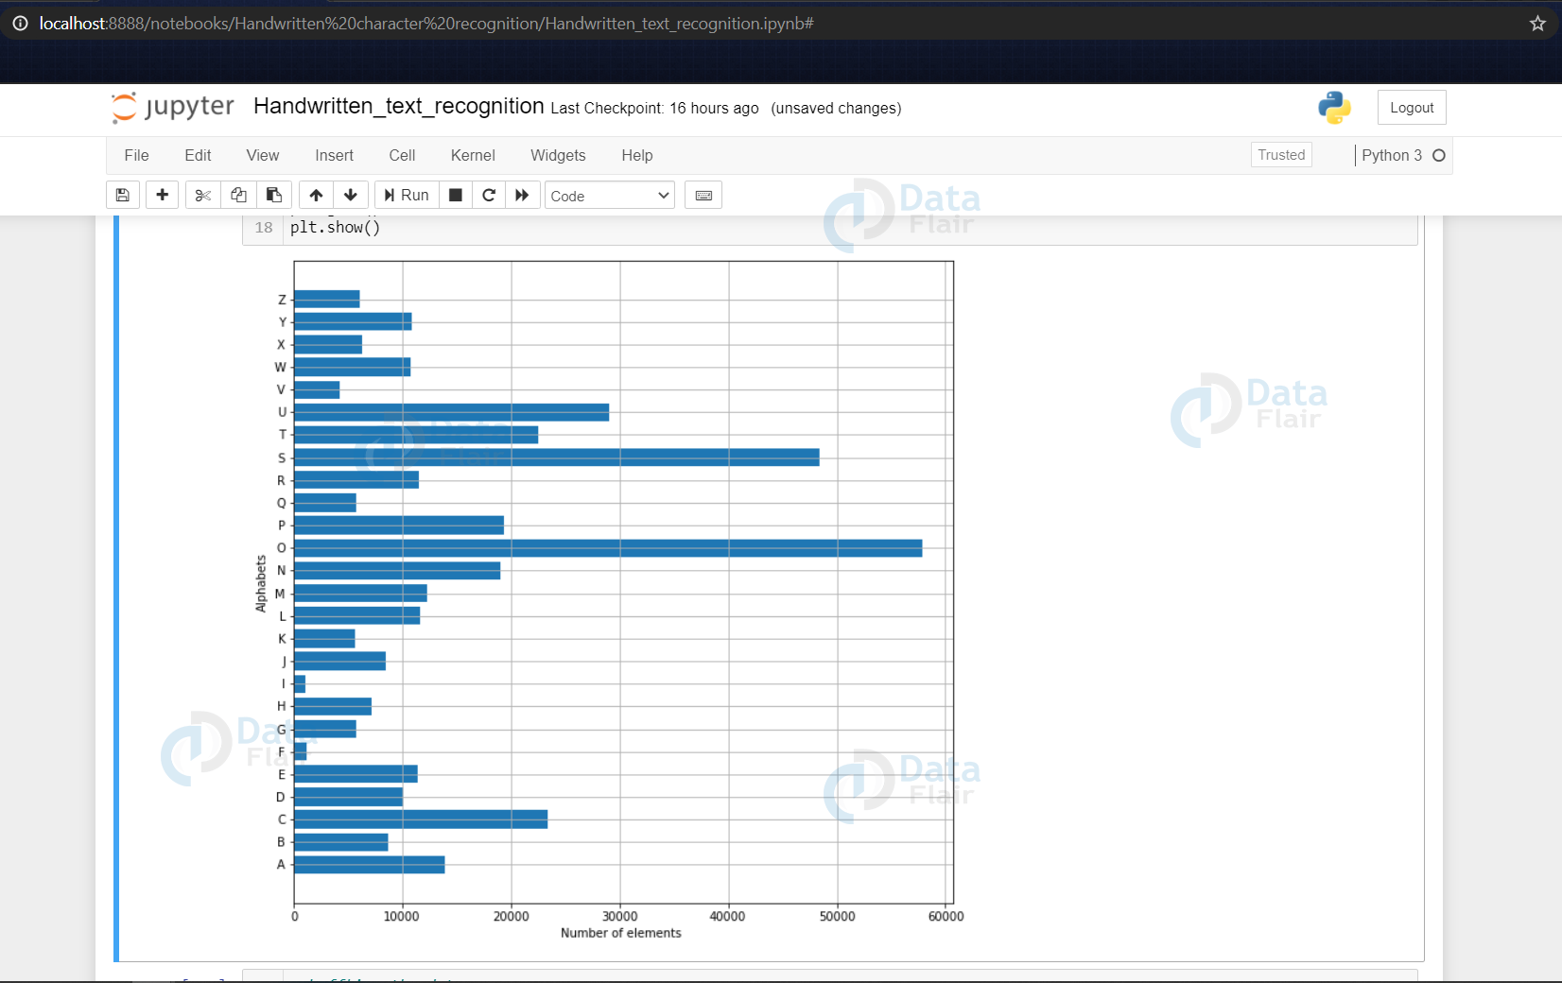

RESULT:
Thus by implementing Character using Artificial Neural Network is verified and executed successfully.

Exp No :3 | Implement the Analysis of X-ray Image using Autoencoders

AIM:
To Implement the analysis of X-ray Image using Autoencoders by using Jupyter.

PROCEDURE:
- In this notebook, I've implemented Medical image denoising using convolutional denoising autoencoders paper for Chest X-Ray images.
- In This paper author proposed a method to contruct a denoising autoencoder, which gives far superior results than that the Median filtering.

PROGRAM:

In[1]:
# Import all the necessary libraries

import numpy as np
import pandas as pd
import os
import matplotlib.pyplot as plt
from keras.preprocessing import image
from keras.models import Sequential, Model
from keras.layers import Dense, Conv2D, MaxPooling2D,MaxPool2D ,UpSampling2D, Flatten, Input
from keras.optimizers import SGD, Adam, Adadelta, Adagrad
from keras import backend as K
import tensorflow as tf
from tensorflow.keras.callbacks import EarlyStopping

Using TensorFlow backend.
Load and preprocess the images
- Read the images in gray scale
- Resize them to size 64x64
- Normalize the pixels

In[2]:
train_images = sorted(os.listdir('../input/chest-xray/normal_xray/'))
train_image = []

for im in train_images:
img = image.load_img('../input/chest-xray/normal_xray/'+ im, target_size=(64,64), color_mode= 'grayscale')
img = image.img_to_array(img)
img = img/255
train_image.append(img)
train_df = np.array(train_image)

Defining Function to plot the images

In[3]:
def show_img(dataset):
f, ax = plt.subplots(1,5)
f.set_size_inches(40, 20)
for i in range(5,10):
ax[i-5].imshow(dataset[i].reshape(64,64), cmap='gray')
plt.show()

Defining a function to add Gaussian noise to our images. In addition we also multiply by a factor of 0.03, as it is the fraction of noise that we want in our picture.

In[4]:
def add_noise(image):
row,col,ch= image.shape
mean = 0
sigma = 1
gauss = np.random.normal(mean,sigma,(row,col,ch))
gauss = gauss.reshape(row,col,ch)
noisy = image + gauss*0.03
return noisy

In[5]:
noise_imgs= []

for img in train_df:

noisy_img = add_noise(img)
noise_imgs.append(noisy_img)

noise_imgs= np.array(noise_imgs)

Display Normal Images in Train Set

In[6]:
show_img(train_df)

OUTPUT:
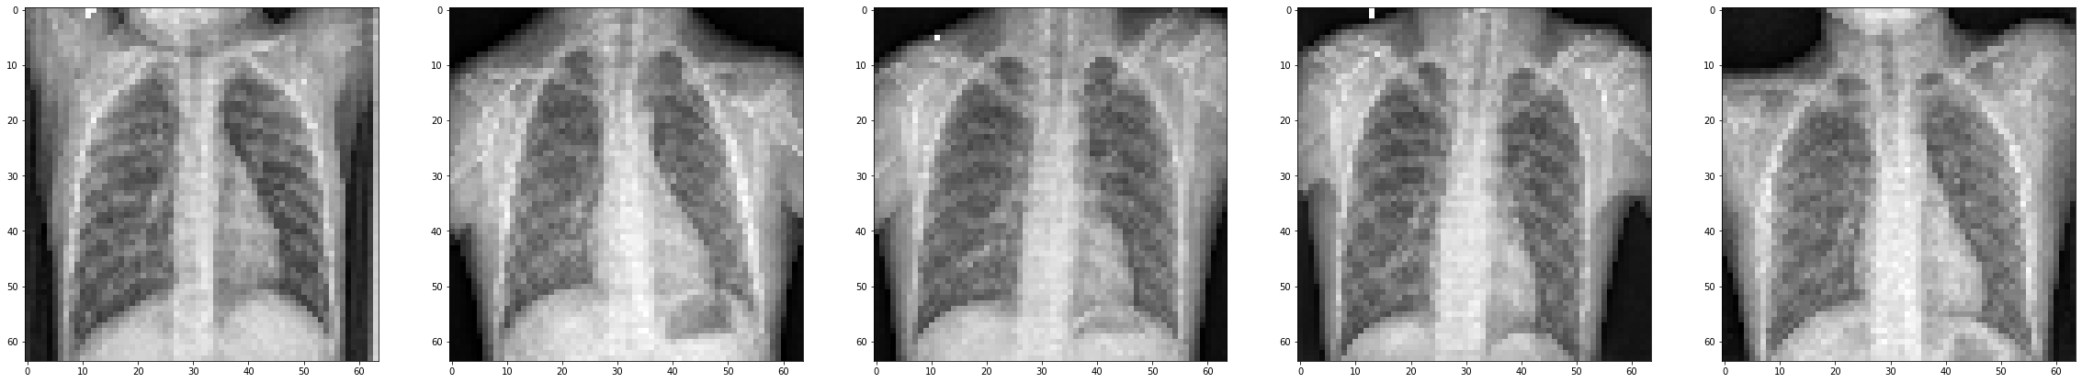

Display Noisy Images

In[7]:
show_img(noise_imgs)

OUTPUT:
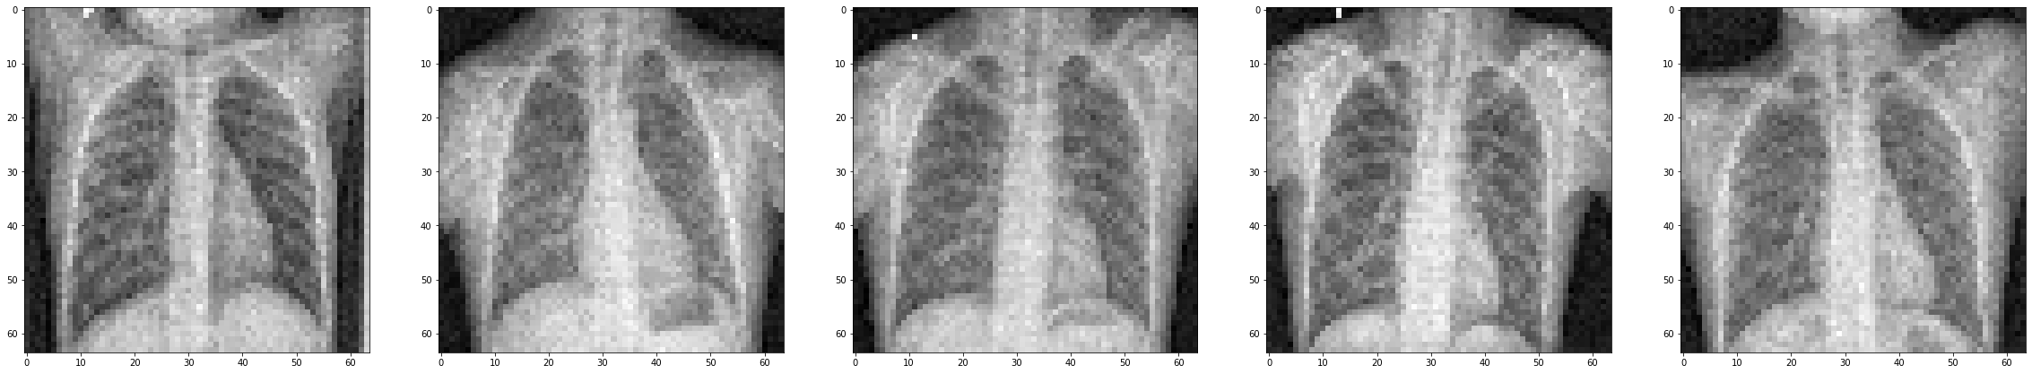

RESULT:
Thus by implementing the Analysis of X-ray Image by using Autoencoders in Jupyter is executed and verified successfully.

Exp No :4 | Implement Speech Recognition using NLP

AIM:
To Implement Speech Recognition using Natural Language Processing.

PROCEDURE:
Natural Language Processing (NLP) helps computers learn, understand, and produce content in human or natural language. Text/character recognition and speech/voice recognition are capable of inputting the information in the system, and NLP helps these applications make sense of this information. NLP-based systems are especially effective for augmenting both human-human communication (like language translation) and human-machine communication (like virtual assistants).

Speech Recognition incorporates computer science and linguistics to identify spoken words and converts them into text. It allows computers to understand human language.

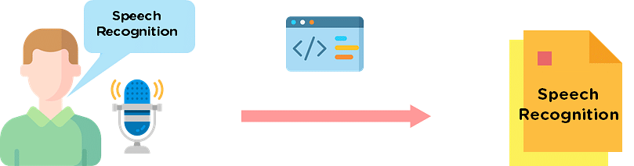

Speech recognition in Python works with algorithms that perform linguistic and acoustic modeling. Acoustic modeling is used to recognize phenones/phonetics in our speech to get the more significant part of speech, as words and sentences.

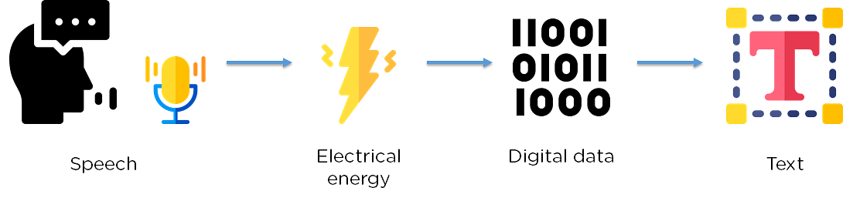

Picking and Installing a Speech Recognition Package

To perform speech recognition in Python, you need to install a speech recognition package to use with Python. There are multiple packages available online. The table below outlines some of these packages and highlights their specialty.
Package | Functionality | Installation
Apiai | Includes natural language processing for identifying a speaker’s intent | $ pip install apiai
Google-cloud-speech | Offers basic speech to text conversion | $pip install virtualenv  virtualenv <your-env>  <your-env>\Scripts\activate  <your-env>\Scripts\pip.exe install  Google cloud speech
Speech Recognition | Offers easy audio processing and microphone accessibility | pip install SpeechRecognition
Watson-developer-cloud | Watson developer cloud is an Artificial Intelligence API that makes creating, debugging, running, and deploying APIs easy. It can be used to perform basic speech recognition tasks. | pip install-upgrade watson-developer  cloud

PROGRAM:
Now, use speech recognition to create a guess-a-word game. The computer will pick a random word, and you have to guess what it is. You start by importing the necessary packages.
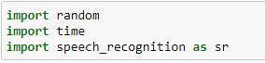
Importing packages
Now, create a function to recognize what is being said from the microphone. The function is the same, but you have to include exception handling in the program.

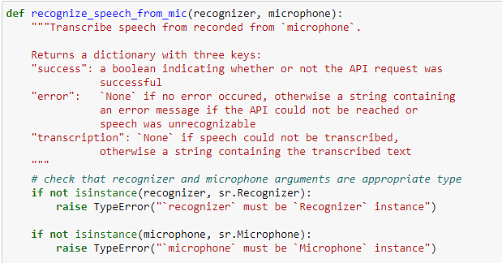
Handling microphone exceptions
Now, initialize your recognizer class and take in the microphone input. You will also check to see if the audio was legible and if the API call malfunctioned.
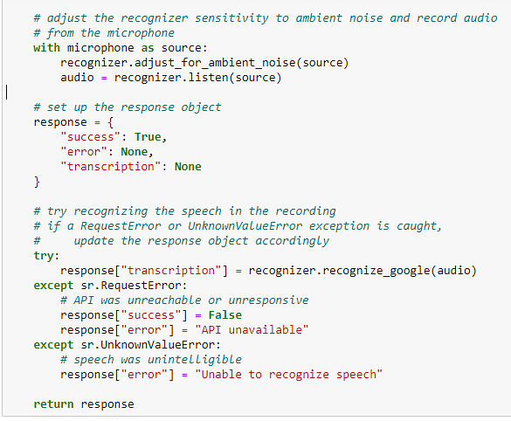
Converting speech to text
Now, initialize the microphone. You will also create a list that contains the various words from which the user will have to guess. You will also give the user the instructions for this game.
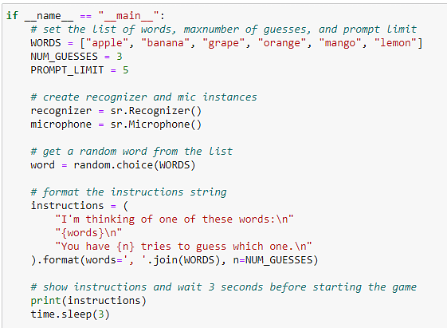
Setting up the microphone
Now, create a function that takes in microphone input thrice, checks it with the selected word, and prints the results.
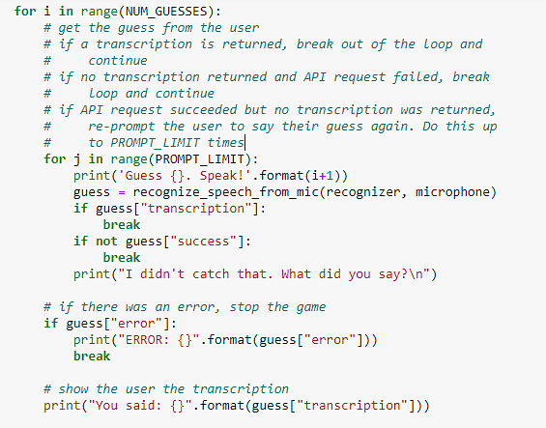

OUTPUT:
Setting up the game

The image below shows the various output messages and the output of the program.
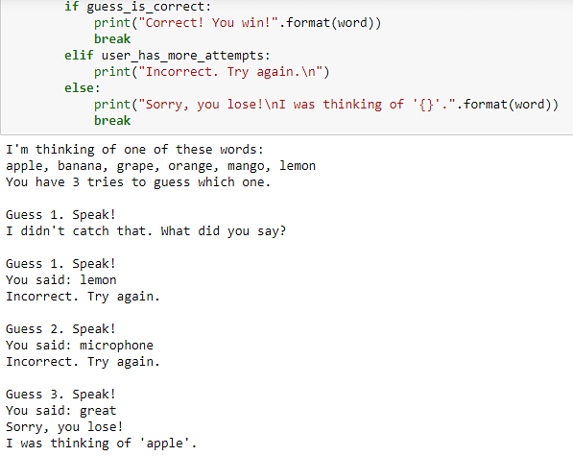
Game output
From the output, you can see that the word chosen was ‘apple’. The user got three guesses and was wrong. You can also see the error message which appeared because the user wasn’t audible.

RESULT:
Thus by using basic plots using Matplotlib in python is successfully executed and verified successfully.

Exp No :5.a | Develop a code to design object detection using CNN

AIM:
To Devolop a Code to Design Object Detection using Convolution Neural Network.

PROCEDURE:
Classification and object detection are the main parts of computer vision. Classification is finding what is in an image and object detection and localisation is finding where is that object in that image. Detection is a more complex problem to solve as we need to find the coordinates of the object in an image.
To Solve this problem R-CNN was introduced by Ross Girshick, Jeff Donahue, Trevor Darrell and Jitendra Malik in 2014. R-CNN stands for Regions with CNN. In R-CNN instead of running classification on huge number of regions we pass the image through selective search and select first 2000 region proposal from the result and run classification on that. In this way instead of classifying huge number of regions we need to just classify first 2000 regions. This makes this algorithm fast compared to previous techniques of object detection.
There are 4 steps in R-CNN. They are as follows :-
- Pass the image through selective search and generate region proposal.
- Calculate IOU (intersection over union) on proposed region with ground truth data and add label to the proposed regions.
- Do transfer learning using the proposed regions with the labels.
- Pass the test image to selective search and then pass the first 2000 proposed regions from the trained model and predict the class of those regions.
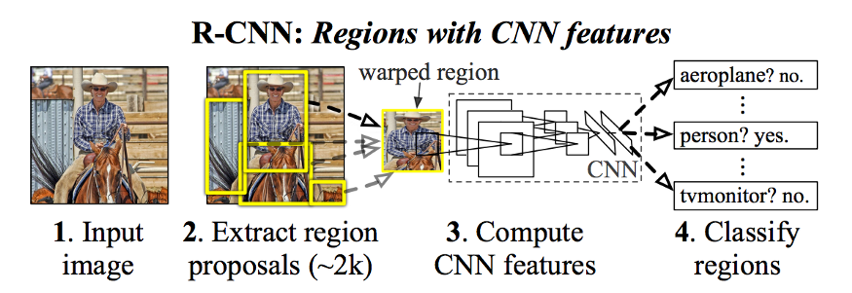
R-CNN

PROGRAM:
The code for implemented RCNN can also be found in the below mentioned repository.
https://github.com/1297rohit/RCNN.git

Once you have downloaded the dataset you can proceed with the steps written below.
import os,cv2,keras
import pandas as pd
import matplotlib.pyplot as plt
import numpy as np
import tensorflow as tf
First step is to import all the libraries which will be needed to implement R-CNN. We need cv2 to perform selective search on the images. To use selective search we need to download opencv-contrib-python. To download that just run pip install opencv-contrib-python in the terminal and install it from pypi.
ss = cv2.ximgproc.segmentation.createSelectiveSearchSegmentation()
After downloading opencv-contrib we need to initialise selective search. For that we have added the above step.
def get_iou(bb1, bb2):
assert bb1['x1'] < bb1['x2']
assert bb1['y1'] < bb1['y2']
assert bb2['x1'] < bb2['x2']
assert bb2['y1'] < bb2['y2'] x_left = max(bb1['x1'], bb2['x1'])
y_top = max(bb1['y1'], bb2['y1'])
x_right = min(bb1['x2'], bb2['x2'])
y_bottom = min(bb1['y2'], bb2['y2']) if x_right < x_left or y_bottom < y_top:
return 0.0 intersection_area = (x_right - x_left) * (y_bottom - y_top) bb1_area = (bb1['x2'] - bb1['x1']) * (bb1['y2'] - bb1['y1'])
bb2_area = (bb2['x2'] - bb2['x1']) * (bb2['y2'] - bb2['y1']) iou = intersection_area / float(bb1_area + bb2_area - intersection_area)
assert iou >= 0.0
assert iou <= 1.0
return iou
train_images=[]
train_labels=[]
for e,i in enumerate(os.listdir(annot)):
try:
if i.startswith("airplane"):
filename = i.split(".")[0]+".jpg"
print(e,filename)
image = cv2.imread(os.path.join(path,filename))
df = pd.read_csv(os.path.join(annot,i))
gtvalues=[]
for row in df.iterrows():
x1 = int(row[1][0].split(" ")[0])

y1 = int(row[1][0].split(" ")[1])
x2 = int(row[1][0].split(" ")[2])
y2 = int(row[1][0].split(" ")[3])

gtvalues.append({"x1":x1,"x2":x2,"y1":y1,"y2":y2})
ss.setBaseImage(image)
ss.switchToSelectiveSearchFast()
ssresults = ss.process()
imout = image.copy()
counter = 0
falsecounter = 0
flag = 0
fflag = 0
bflag = 0
for e,result in enumerate(ssresults):
if e < 2000 and flag == 0:
for gtval in gtvalues:
x,y,w,h = result
iou = get_iou(gtval,{"x1":x,"x2":x+w,"y1":y,"y2":y+h})
if counter < 30:
if iou > 0.70:
timage = imout[y:y+h,x:x+w]
resized = cv2.resize(timage, (224,224), interpolation = cv2.INTER_AREA)
train_images.append(resized)
train_labels.append(1)
counter += 1
else :
fflag =1
if falsecounter <30:
if iou < 0.3:
timage = imout[y:y+h,x:x+w]
resized = cv2.resize(timage, (224,224), interpolation = cv2.INTER_AREA)
train_images.append(resized)
train_labels.append(0)
falsecounter += 1
else :
bflag = 1
if fflag == 1 and bflag == 1:

print("inside")
flag = 1
except Exception as e:
print(e)
print("error in "+filename)
continue

OUTPUT:
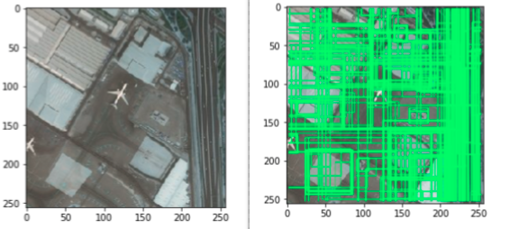
Running selective search on an image and getting proposed regions

RESULT:
Thus the code to design Object detection using CNN is executed and verified successfully.

Exp No :5.b | Develop a Code to Design Classification for Traffic Analysis using CNN

AIM:
To Devolop a Code to Design Classification for Trafic Analysis using Convolution Neural Network.

PROCEDURE:
A convolutional Neural Network is a Deep Learning network used to pick up features from the image. Initially, they take the input images and then find out the lines, gradients, shapes, and borders from the image.
Then further, Convolutional Layers help in processing the outputs to capture eyes, faces, etc. CNN contains many convolutional layers assembled on top of each other, each one competent of recognizing more sophisticated shapes. With two or three convolutional layers it is viable to recognize handwritten digits and with 25 layers it is possible to differentiate human faces.
Traffic Signs Recognition using CNN and Keras in Python
Here we will be using this concept for the recognition of traffic signs.
Importing Libraries
- Pandas – Use to load the data frame in a 2D array format.
- NumPy – NumPy arrays are very fast and can perform large computations in a very short time.
- Matplotlib – This library is used to draw visualizations.
- Sklearn – It contains multiple libraries having pre-implemented functions of model development and evaluation.
- OpenCV – This library mainly focused on image processing and handling.
- Tensorflow – It provides a range of functions to achieve complex functionalities with single lines of code.

PROGRAM:
- Python3

import matplotlib.image as mpimg
import os

from tensorflow.keras.callbacks import EarlyStopping
from tensorflow.keras.preprocessing import image_dataset_from_directory
from tensorflow.keras.preprocessing.image import ImageDataGenerator, load_img
from keras.utils.np_utils import to_categorical

from tensorflow.keras.utils import image_dataset_from_directory
from tensorflow.keras.optimizers import Adam
from tensorflow.keras.layers import Conv2D, MaxPooling2D
from tensorflow.keras.layers import Activation, Dropout, Flatten, Dense
from tensorflow.keras.models import Sequential
from keras import layers
from tensorflow import keras
from tensorflow.keras.layers.experimental.preprocessing import Rescaling
from sklearn.model_selection import train_test_split

import matplotlib.pyplot as plt
import tensorflow as tf
import pandas as pd
import numpy as np
from glob import glob
import cv2

import warnings
warnings.filterwarnings('ignore')

Loading and Extracting the Dataset
The dataset has 58 classes of Traffic Signs and a label.csv file. The folder is in zip format. To unzip the dataset, we will run the code below.
- Python3
# Extracting the compressed dataset.
from zipfile import ZipFile data_path
= '/content/traffic-sign-dataset-classification.zip' with
ZipFile(data_path, 'r') as zip
: zip.extractall()
Data Visualization
Data visualization means the visualization of data to understand the key features of the dataset.
- Python3
# path to the folder containing our dataset
dataset = '../content/traffic_Data/DATA'

# path of label file
labelfile = pd.read_csv('labels.csv')
Once we load the dataset, now let’s visualize some random images from the different folders. For that, we will use plt.imshow() command.
- Python3
# Visualize some images from the dataset
img = cv2.imread("/content/traffic_Data/DATA/10/010_0011.png")
plt.imshow(img)

OUTPUT:
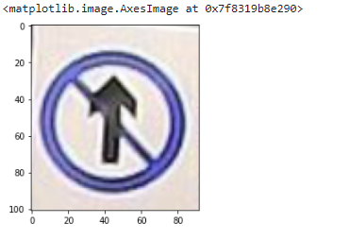
PROGRAM:
- Python3
img = cv2.imread("/content/traffic_Data/DATA/23/023_0001.png")
plt.imshow(img)
OUTPUT:
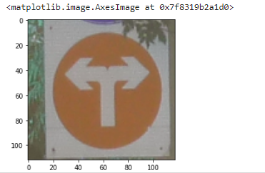
RESULT:
Thus the Code to Design for the Classification for Traffic Analysis using CNN is executed and verified successfully.

Exp No :6 | Implement Online Fraud Detection of Share Market Data using any one of the Data Analytics Tools

AIM:
To Implement Online Fraud Detection of Share Market Data using Data Analytics Tools.

PROCEDURE:
Fraud can take place in many forms, and it affects all kinds of industries but the degree of harm is different for different industries. The sectors which frequently deal with fraud detection use several techniques to deal with the fraud. The main thing that they must do is to know the reason behind the fraud. Data analytics is the best tool that can help you know the reason behind frequent frauds at your workplace.
The main advantage of using data analytics for fraud detection is that they can handle a huge amount of data at once. The data surely helps you know the area which suffers the fraud mostly and how to deal with it in the right manner. Data analytics also helps in tracking the trends and possible problems substantially faster than people could do without the help of any technological tool. Some of the advantages of using data analytics for fraud detection include:
- Automates the repetitive tests which help in saving a lot of time
- Searches 100% of your transactions automatically for fraud indicators.
- Easily merge, normalize, and compare data from different systems.
- Identifies the fraud quickly before it becomes front-page news.
- Realign resources to focus detection efforts on suspicious transactions.
- Calculates the impact of fraud more accurately.
- Reduces the risk of sampling errors and improves internal controls

PROGRAM:
Fraud Detection in Python
Course Description
A typical organization loses an estimated 5% of its yearly revenue to fraud. In this course, learn to fight fraud by using data. Apply supervised learning algorithms to detect fraudulent behavior based upon past fraud, and use unsupervised learning methods to discover new types of fraud activities.
Fraudulent transactions are rare compared to the norm. As such, learn to properly classify imbalanced datasets.
The course provides technical and theoretical insights and demonstrates how to implement fraud detection models. Finally, get tips and advice from real-life experience to help prevent common mistakes in fraud analytics.
Imports
In [1]:

import warnings
warnings.filterwarnings('ignore')
warnings.simplefilter('ignore')
In [2]:
import pandas as pd
import matplotlib.pyplot as plt
from matplotlib.patches import Rectangle
import numpy as np
from pprint import pprint as pp
import csv
from pathlib import Path
import seaborn as sns
from itertools import product
import string

import nltk
from nltk.corpus import stopwords
from nltk.stem.wordnet import WordNetLemmatizer

from imblearn.over_sampling import SMOTE
from imblearn.over_sampling import BorderlineSMOTE
from imblearn.pipeline import Pipeline

from sklearn.linear_model import LinearRegression, LogisticRegression
from sklearn.model_selection import train_test_split, GridSearchCV
from sklearn.tree import DecisionTreeClassifier
from sklearn.metrics import r2_score, classification_report, confusion_matrix, accuracy_score, roc_auc_score, roc_curve, precision_recall_curve, average_precision_score
from sklearn.metrics import homogeneity_score, silhouette_score
from sklearn.ensemble import RandomForestClassifier, VotingClassifier
from sklearn.preprocessing import MinMaxScaler
from sklearn.cluster import MiniBatchKMeans, DBSCAN

import gensim
from gensim import corpora
Pandas Configuration Options
In [3]:
pd.set_option('display.max_columns', 700)

pd.set_option('display.max_rows', 400)

pd.set_option('display.min_rows', 10)
pd.set_option('display.expand_frame_repr', True)
Data File Objects
In [4]:
data = Path.cwd() / 'data' / 'fraud_detection'

ch1 = data / 'chapter_1'
cc1_file = ch1 / 'creditcard_sampledata.csv'
cc3_file = ch1 / 'creditcard_sampledata_3.csv'

ch2 = data / 'chapter_2'
cc2_file = ch2 / 'creditcard_sampledata_2.csv'

ch3 = data / 'chapter_3'
banksim_file = ch3 / 'banksim.csv'
banksim_adj_file = ch3 / 'banksim_adj.csv'
db_full_file = ch3 / 'db_full.pickle'
labels_file = ch3 / 'labels.pickle'
labels_full_file = ch3 / 'labels_full.pickle'
x_scaled_file = ch3 / 'x_scaled.pickle'
x_scaled_full_file = ch3 / 'x_scaled_full.pickle'

ch4 = data / 'chapter_4'
enron_emails_clean_file = ch4 / 'enron_emails_clean.csv'
cleantext_file = ch4 / 'cleantext.pickle'
corpus_file = ch4 / 'corpus.pickle'
dict_file = ch4 / 'dict.pickle'
ldamodel_file = ch4 / 'ldamodel.pickle'

df = pd.read_csv(cc3_file)
Explore the features available in your dataframe
In [6]:
df.info()

OUTPUT:

<class 'pandas.core.frame.DataFrame'>
RangeIndex: 5050 entries, 0 to 5049

Data columns (total 31 columns):
# Column Non-Null Count Dtype
--- ------ -------------- -----
0 Unnamed: 0 5050 non-null int64
1 V1 5050 non-null float64
2 V2 5050 non-null float64
3 V3 5050 non-null float64
4 V4 5050 non-null float64
5 V5 5050 non-null float64
6 V6 5050 non-null float64
7 V7 5050 non-null float64
8 V8 5050 non-null float64
9 V9 5050 non-null float64
10 V10 5050 non-null float64
11 V11 5050 non-null float64
12 V12 5050 non-null float64
13 V13 5050 non-null float64
14 V14 5050 non-null float64
15 V15 5050 non-null float64
16 V16 5050 non-null float64
17 V17 5050 non-null float64
18 V18 5050 non-null float64
19 V19 5050 non-null float64
20 V20 5050 non-null float64
21 V21 5050 non-null float64
22 V22 5050 non-null float64
23 V23 5050 non-null float64
24 V24 5050 non-null float64
25 V25 5050 non-null float64
26 V26 5050 non-null float64
27 V27 5050 non-null float64
28 V28 5050 non-null float64
29 Amount 5050 non-null float64
30 Class 5050 non-null int64
dtypes: float64(29), int64(2)

memory usage: 1.2 MB

PROGRAM:

# Count the occurrences of fraud and no fraud and print them
occ = df['Class'].value_counts()
occ

OUTPUT:
0 5000
1 50
Name: Class, dtype: int64

PROGRAM:
# Print the ratio of fraud cases
ratio_cases = occ/len(df.index)
print(f'Ratio of fraudulent cases: {ratio_cases[1]}\nRatio of non-fraudulent cases: {ratio_cases[0]}')

OUTPUT:

Ratio of fraudulent cases: 0.009900990099009901
Ratio of non-fraudulent cases: 0.9900990099009901

RESULT:
Thus the Implementing Online Fraud Detection of Share Market Data using Data Analytics Tools in Python is executed and verified successfully.

Exp No :7 | Implement Image Augmentation using Deep RBM

AIM:
To perform Implement Image Augmentation using Deep Restricted Boltzmann Machine(RBM) by using python .

PROCEDURE:
Restricted Boltzmann Machine (RBM) is a two-layered neural network the first layer is referred to as a visible layer and the second layer is referred to as a hidden layer. RBM is also known as shallow neural networks because it has only two layers deep. RBM was invented by Paul Smolensky in 1986 with name Harmonium and later by Geoffrey Hinton who in 2006 proposed Contrastive Divergence (CD) as a method to train them.
RBM can be used for dimensionality reduction, feature extraction, and collaborative filtering.

How it works
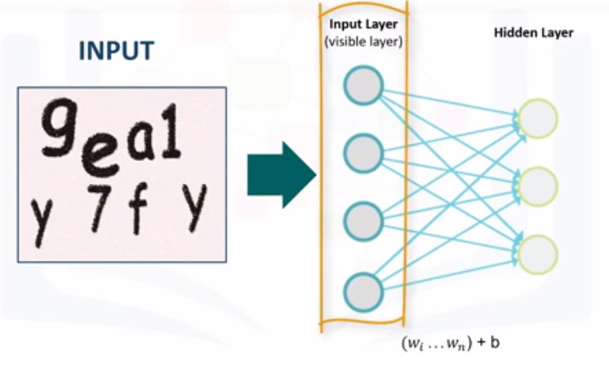
PROGRAM:
Image Augmentation for Deep Learning
- Generate augmented images using ImageDataGenerator in Keras
- Generate custom augmented images using Contrast Stretching, Histogram Equalization, Adaptive Histogram Equalization
- Use image augmentation for training convolutional neural network on CIFAR-10 dataset

In [1]:
from __future__ import print_function
%matplotlib inline
import matplotlib.pyplot as plt

import numpy as np
from skimage.io import imread
from skimage import exposure, color
from skimage.transform import resize

import keras
from keras import backend as K
from keras.datasets import cifar10
from keras.models import Sequential
from keras.layers import Dense, Dropout, Flatten
from keras.layers import Conv2D, MaxPooling2D
from keras.preprocessing.image import ImageDataGenerator
Using TensorFlow backend.

Experimenting with ImageDataGenerator
In [2]:
# define function to generate images

def imgGen(img, zca=False, rotation=0., w_shift=0., h_shift=0., shear=0., zoom=0., h_flip=False, v_flip=False, preprocess_fcn=None, batch_size=9):
datagen = ImageDataGenerator(
zca_whitening=zca,
rotation_range=rotation,
width_shift_range=w_shift,
height_shift_range=h_shift,
shear_range=shear,
zoom_range=zoom,
fill_mode='nearest',
horizontal_flip=h_flip,
vertical_flip=v_flip,
preprocessing_function=preprocess_fcn,
data_format=K.image_data_format())

datagen.fit(img)

i=0
for img_batch in datagen.flow(img, batch_size=9, shuffle=False):
for img in img_batch:
plt.subplot(330 + 1 + i)
plt.imshow(img)
i=i+1
if i >= batch_size:
break
plt.show()
# visualize the image
img = imread("img/cat.jpg")
plt.imshow(img)
plt.show()

# reshape it to prepare for data generator
img = img.astype('float32')
img /= 255
h_dim = np.shape(img)[0]
w_dim = np.shape(img)[1]
num_channel = np.shape(img)[2]
img = img.reshape(1, h_dim, w_dim, num_channel)
print(img.shape)

# generate images using function imgGen
imgGen(img, rotation=30, h_shift=0.5)

OUTPUT:
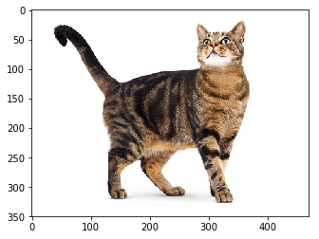
(1, 350, 470, 3)
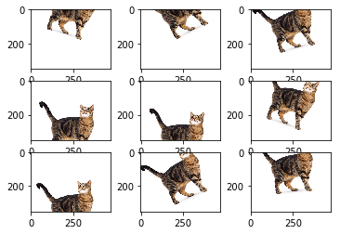

RESULT:
Thus Implementing Image Augmentation by using deep RBM in Python is executed and verified successfully.

Exp No :8 | Implement Sentiment Analysis using LSTM

AIM:
To Implement Sentiment Analysis using Long short-term memory.

PROCEDURE:
- Load in and visualize the data
- Data Processing — convert to lower case
- Data Processing — Remove punctuation
- Data Processing — Create list of reviews
- Tokenize — Create Vocab to Int mapping dictionary
- Tokenize — Encode the words
- Tokenize — Encode the labels
- Analyze Reviews Length
- Removing Outliers — Getting rid of extremely long or short reviews
- Padding / Truncating the remaining data
- Training, Validation, Test Dataset Split
- Dataloaders and Batching
- Define the LSTM Network Architecture
- Define the Model Class
- Training the Network
- Testing (on Test data and User- generated data)

PROGRAM:
Load in and visualize the data
We are using IMDB movies review dataset. If it is stored in your machine in a txt file then we just load it in
# read data from text files
with open(‘data/reviews.txt’, ‘r’) as f:
reviews = f.read()
with open(‘data/labels.txt’, ‘r’) as f:
labels = f.read()print(reviews[:50])
print()
print(labels[:26])

OUTPUT:

bromwell high is a cartoon comedy . it ran at the same time as some other programs about school life such as teachers . my yearspositive

negative
positive

PROGRAM:
Analyze Reviews Length
import pandas as pd
import matplotlib.pyplot as plt
%matplotlib inlinereviews_len = [len(x) for x in reviews_int]
pd.Series(reviews_len).hist()
plt.show()pd.Series(reviews_len).describe()

OUTPUT:
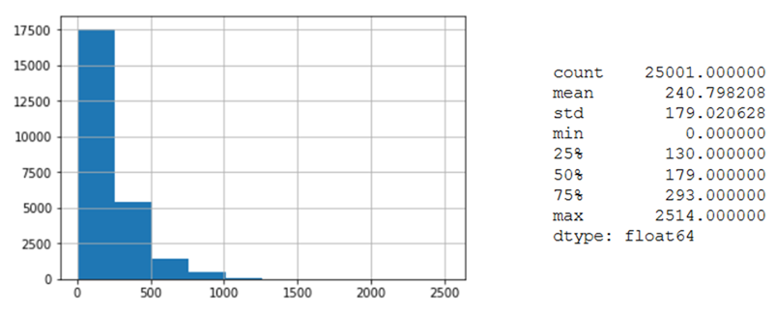

RESULT:
Thus by Implementing Sentimental Analysis using LSTM is executed and verified successfully.

Exp No :9 | Mini Project: Number plate recognition of traffic video Analysis

AIM:
To perform Number Plate Recognition of Traffic Video Analysis.
PROCEDURE:
Recognizing a Car License Plate is a very important task for a camera surveillance-based security system. We can extract the license plate from an image using some computer vision techniques and then we can use Optical Character Recognition to recognize the license number. Here I will guide you through the whole procedure of this task.
Requirements:
opencv-python 3.4.2
numpy 1.17.2
skimage 0.16.2
tensorflow 1.15.0
imutils 0.5.3
Example:
Input:
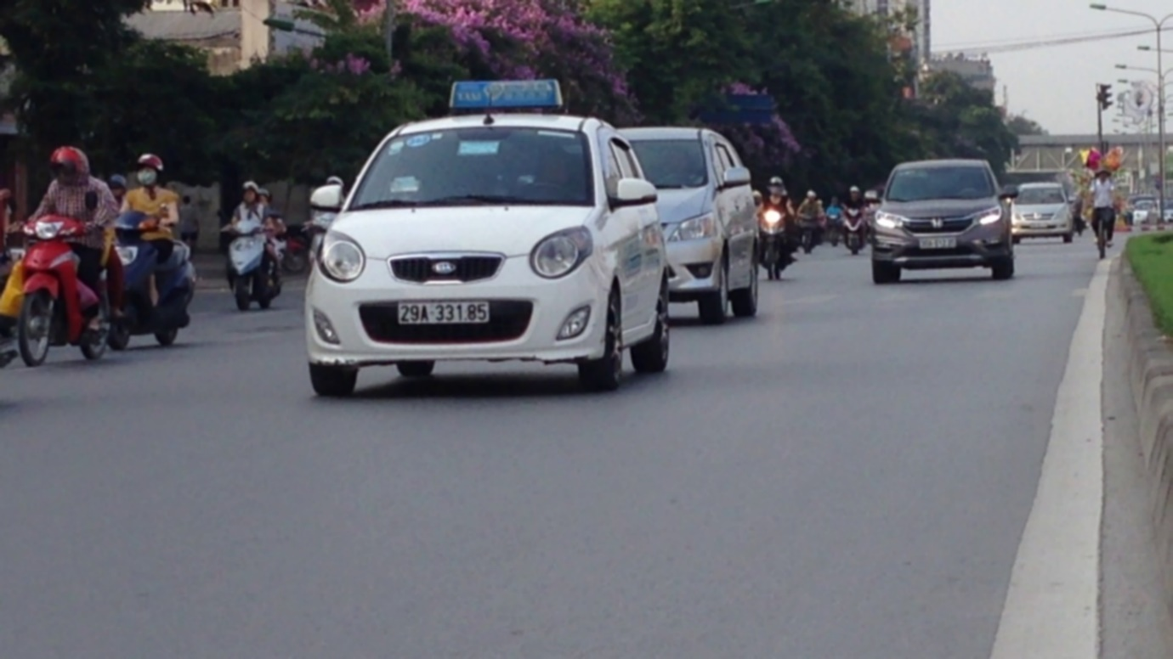
Output:
29A33185
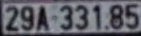

Approach:

- Find all the contours in the image.
- Find the bounding rectangle of every contour.
- Compare and validate the sides ratio and area of every bounding rectangle with an average license plate.
- Apply image segmentation in the image inside the validated contour to find characters in it.
- Recognize characters using an OCR.
Methodology:
1. To reduce the noise we need to blur the input Image with Gaussian Blur and then convert it to grayscale.
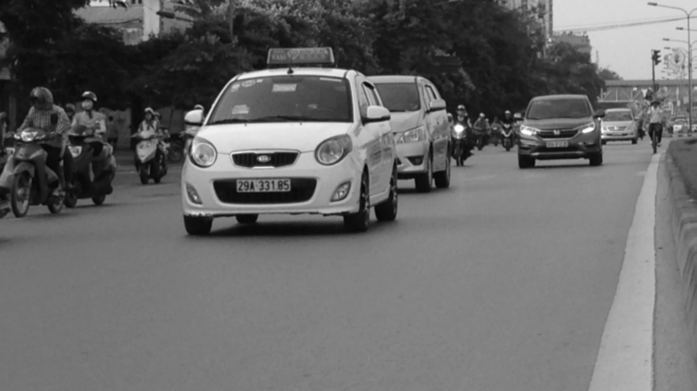

2. Find vertical edges in the image.
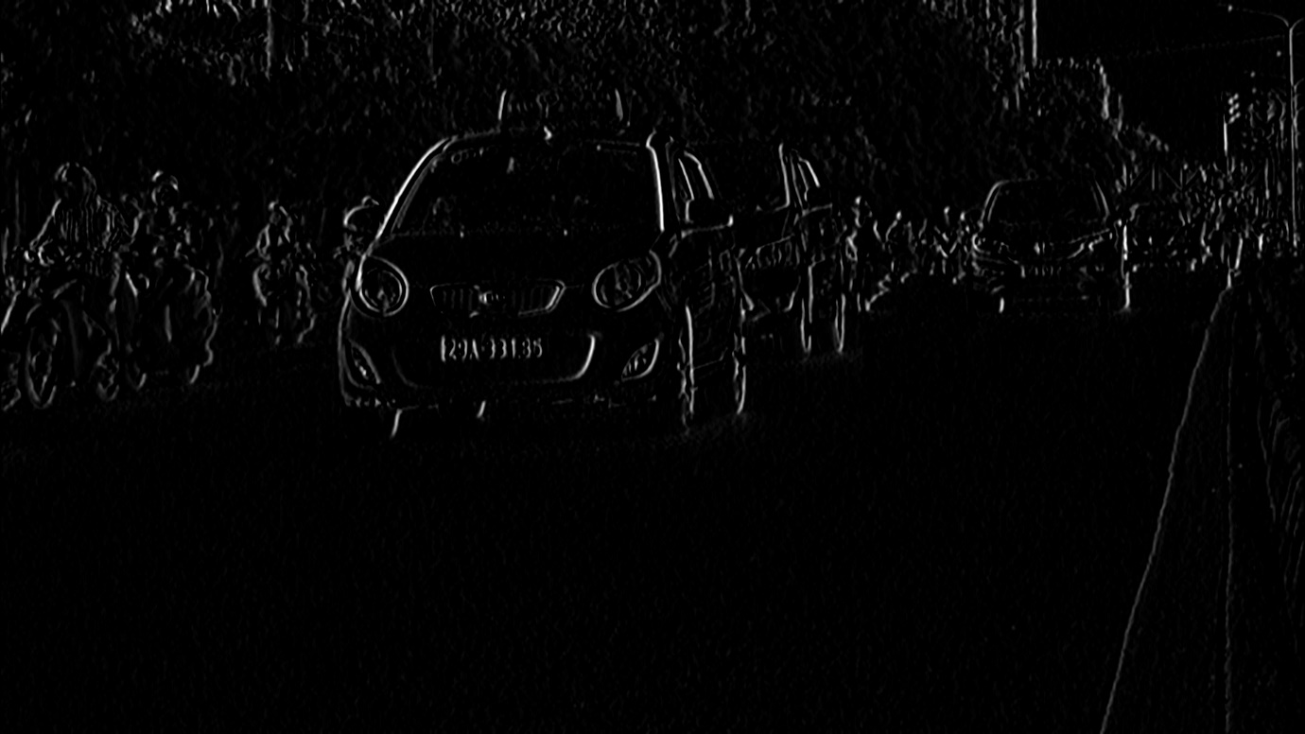

3. To reveal the plate we have to binarize the image. For this apply Otsu’s Thresholding on the vertical edge image. In other thresholding methods, we have to choose a threshold value to binarize the image but Otsu’s Thresholding determines the value automatically.
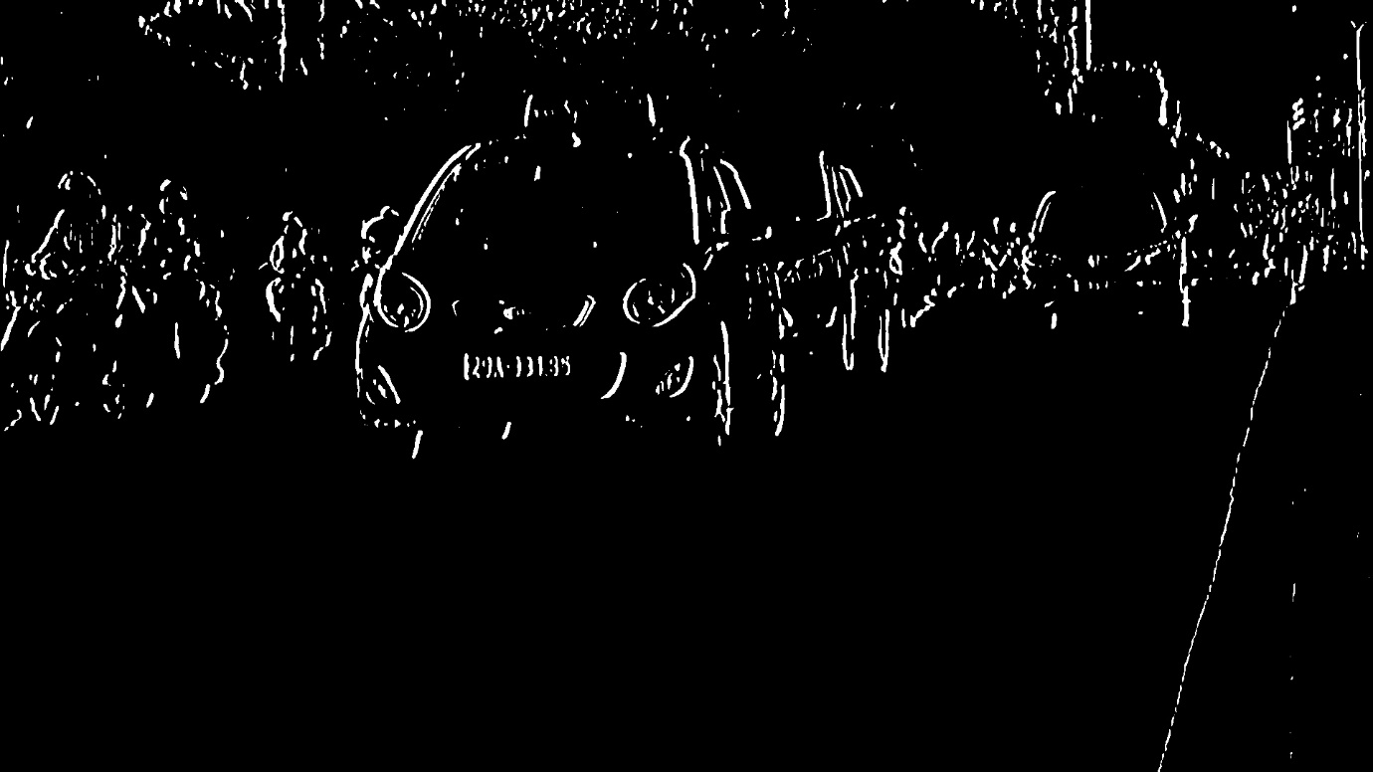

4. Apply Closing Morphological Transformation on the thresholded image. Closing is useful to fill small black regions between white regions in a thresholded image. It reveals the rectangular white box of license plates.

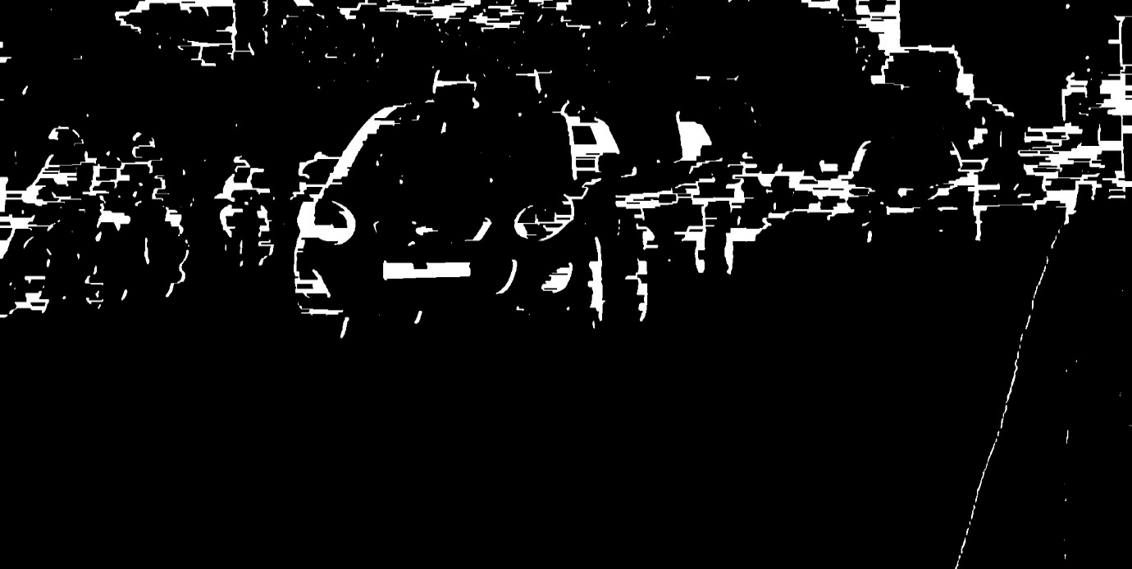

5. To detect the plate we need to find contours in the image. It is important to binarize and morph the image before finding contours so that it can find a more relevant and less number of contours in the image. If you draw all the extracted contours on the original image, it would look like this:
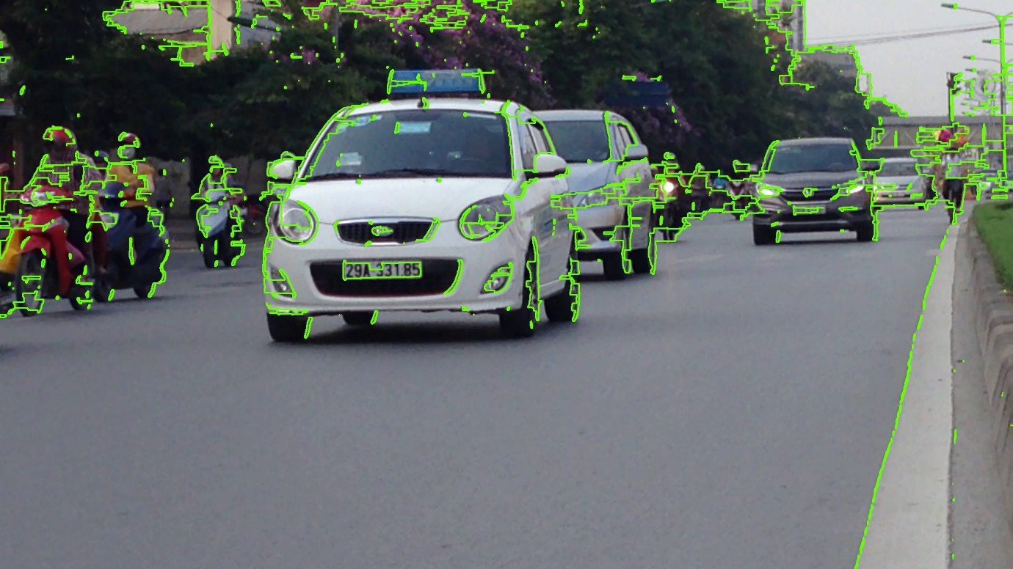

6. Now find the minimum area rectangle enclosed by each of the contours and validate their side ratios and area. We have defined the minimum and maximum area of the plate as 4500 and 30000 respectively.
7. Now find the contours in the validated region and validate the side ratios and area of the bounding rectangle of the largest contour in that region. After validating you will get a perfect contour of a license plate. Now extract that contour from the original image. You will get the image of the plate:

PROGRAM:
def clean_plate(self, plate):

gray = cv2.cvtColor(plate, cv2.COLOR_BGR2GRAY)
thresh = cv2.adaptiveThreshold(gray, 255,
cv2.ADAPTIVE_THRESH_GAUSSIAN_C,
cv2.THRESH_BINARY, 11, 2)

_, contours, _ = cv2.findContours(thresh.copy(),
cv2.RETR_EXTERNAL,
cv2.CHAIN_APPROX_NONE)

if contours:

areas = [cv2.contourArea(c) for c in contours]

# index of the largest contour in the
# areas array
max_index = np.argmax(areas)

max_cnt = contours[max_index]
max_cntArea = areas[max_index]
x, y, w, h = cv2.boundingRect(max_cnt)

if not self.ratioCheck(max_cntArea,
plate.shape[1],
plate.shape[0]):
return plate, False, None

return plate, True, [x, y, w, h]

else:
return plate, False, None

def ratioCheck(self, area, width, height):

min = self.min_area
max = self.max_area

ratioMin = 3
ratioMax = 6

ratio = float(width) / float(height)

if ratio < 1:
ratio = 1 / ratio

if (area < min or area > max) or (ratio < ratioMin or ratio > ratioMax):
return False

return True
8. To recognize the characters on the license plate precisely, we have to apply image segmentation. That first step is to extract the value channel from the HSV format of the plate’s image. It would look like.

9. Now apply adaptive thresholding on the plate’s value channel image to binarize it and reveal the characters. The image of the plate can have different lighting conditions in different areas, in that case, adaptive thresholding can be more suitable to binarize because it uses different threshold values for different regions based on the brightness of the pixels in the region around it.
10. After binarizing apply bitwise not operation on the image to find the connected components in the image so that we can extract character candidates.
11. Construct a mask to display all the character components and then find contours in the mask. After extracting the contours take the largest one, find its bounding rectangle and validate side ratios.
12. After validating the side ratios find the convex hull of the contour ad draws it on the character candidate mask. The mask would look like-

13. Now find all the contours in the character candidate mask and extract those contour areas from the plate’s value thresholded image, you will get all the characters separately.

OUTPUT:
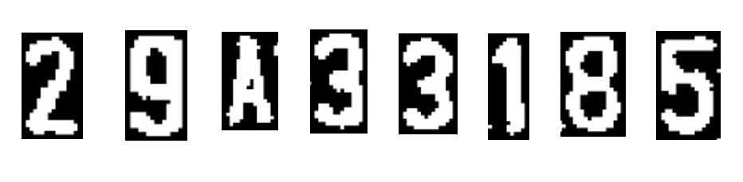

RESULT:
Thus the Number Plate Recognition of Traffic Video Analysis by using Python is executed and verified successfully.

